1. 120-150v

2. 122v

3. (see below)

4. 122v for wall outlet, 4v for 4-pin, sata, and floppy

5. (see below)

6. PCI: (usually network cards) PCIEx16: (usually for graphics cards) PCIx1: (sound cards, raid controllers)

See photos below for #6

7. They are colored for dual channel (see photo below)

8. (see photo below)

9. (see photo below)

2. 122v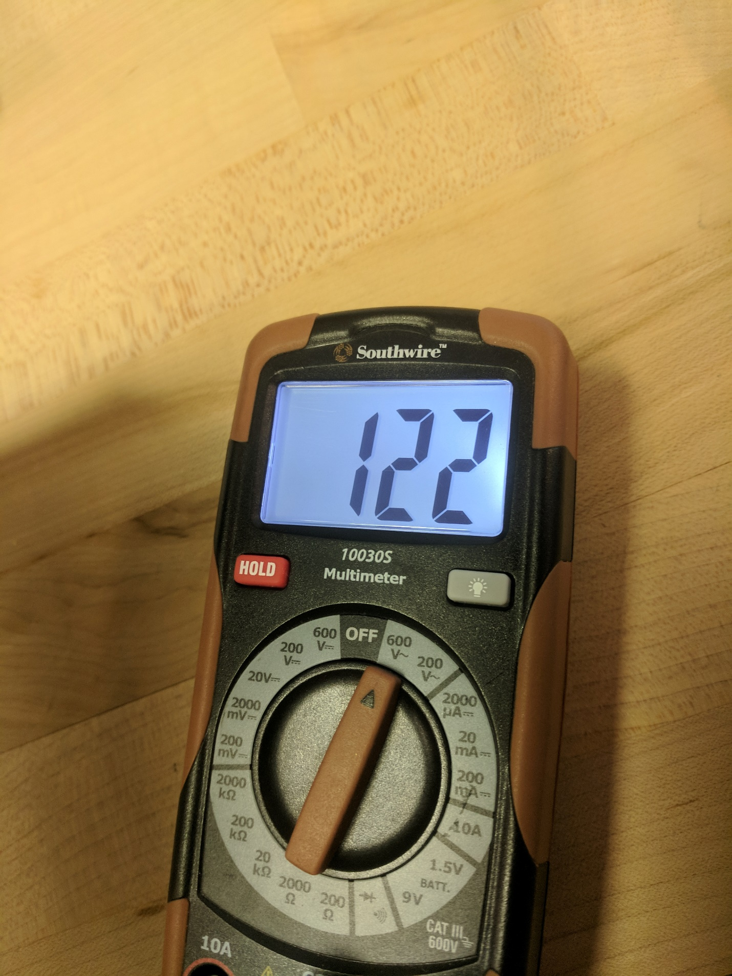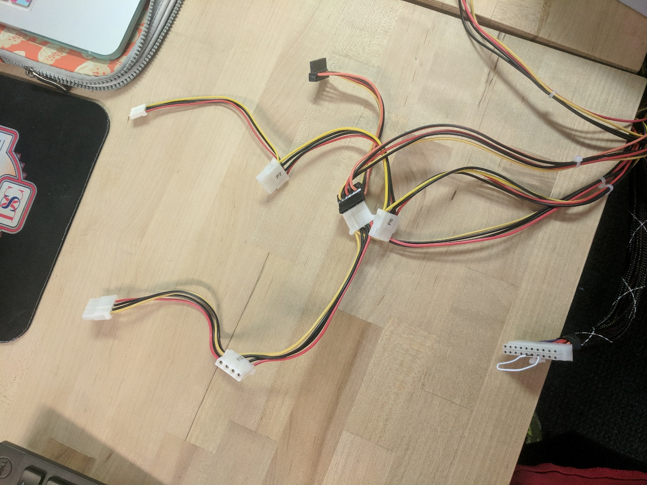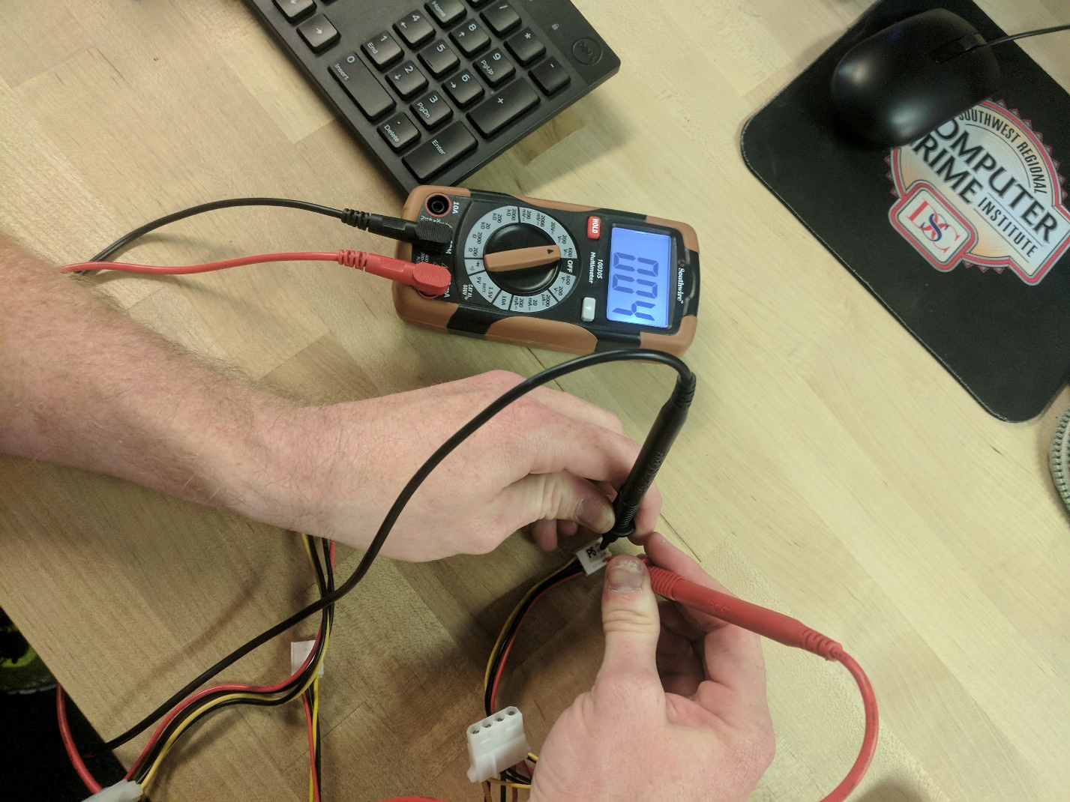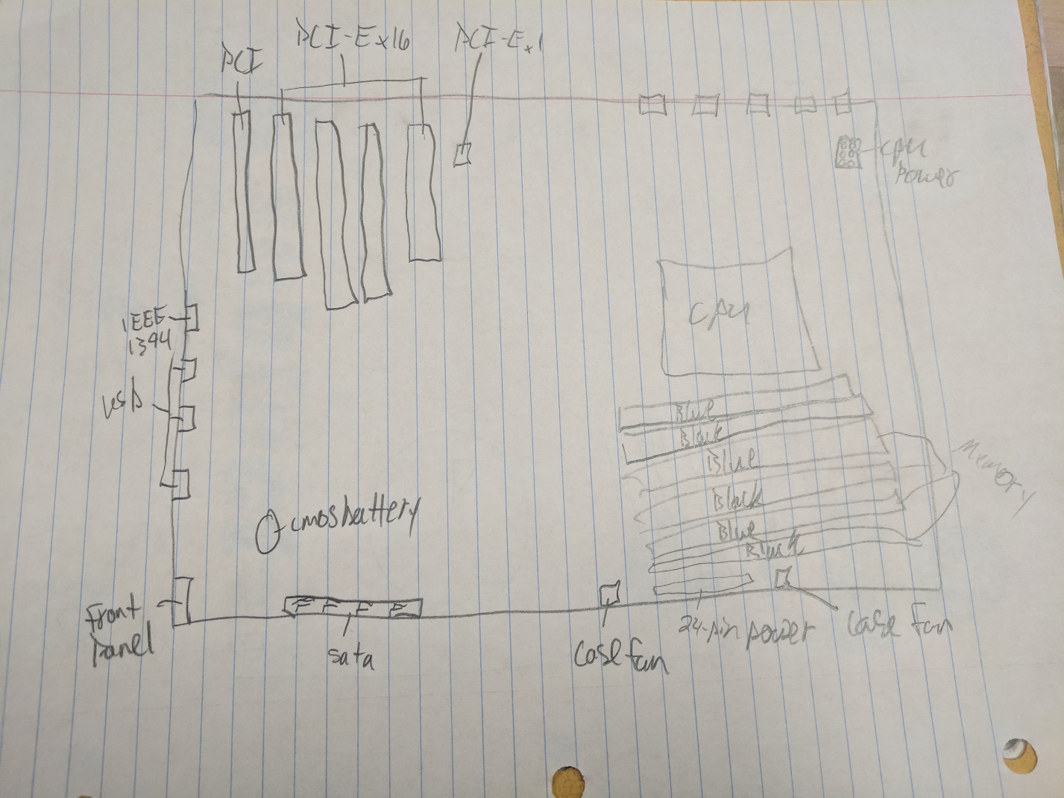

24-pin power supply connector

Floppy power supply

4-pin peripheral

Sata Connectors